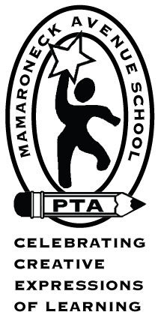

MAS PTA Meeting Agenda
Tuesday, March 10, 2020

- Treasurer’s Report
- Outdoor Classroom – final design and vote
- Parent Outreach – 3/1 Ice Skating recap
  - Parent/Faculty Kickball game to be scheduled for May.
- Box Tops Month
- Event scheduling generally for remainder of the year
- St. Patrick’s Day Parade – Saturday 3/14, meet 11:30 @ Dorry’s Diner
- International Dinner – Postponed: Make-up date TBD
- Fifth Grade Fundraiser - Paint Night, Friday 3/27 @ 6pm.
  - Grades 3-5 only
  - Volunteers needed
- Science Month
  - Assembly “The Magic of Science,” Monday 3/23
  - Meet the Scientist Day - Cancelled
  - Science Fair, Tuesday 4/14 @ 6:30pm
  - Leadership for next year
- Next PTA Meeting: Tuesday 4/14 @ 7:30pm (after the Science Fair): District presentation of 2020-21 budget and PTA vote on the budget
- Family Fun Night – Friday 4/24, prizes/donations needed; volunteers for event
- Town Hall with Dr. Ricca

Our next meeting is Tuesday, April 14th after the Science Fair.
See you there!

